Maternal Health Risk Analysis Project Submission

Task 1: Prepare and clean the dataset
Activity number | Activity
Import and clean maternal health data
- Acquire and load the data
- Remove duplicates
- Remove any personally identifiable information (PII)
- Handle missing values using median imputation
- Normalize data values

Screenshot required for project evaluation
- Summary statistics (mean and standard deviation) of normalized data

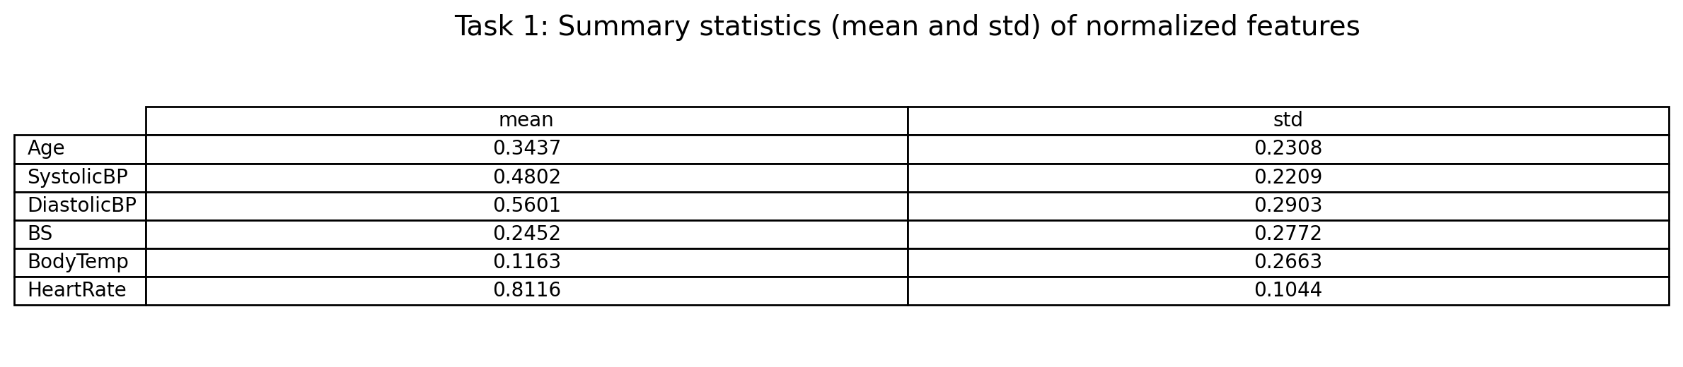

Task 2: Build and evaluate a supervised patient risk scoring model
Activity number | Activity
Select features and create training–testing datasets

- Identify the features (X) and target (y) columns
- Perform an 80:20 train-test split, with stratification and random_state=42

Screenshot required for project evaluation
- Target distribution for training and test sets (e.g., counts of each class)

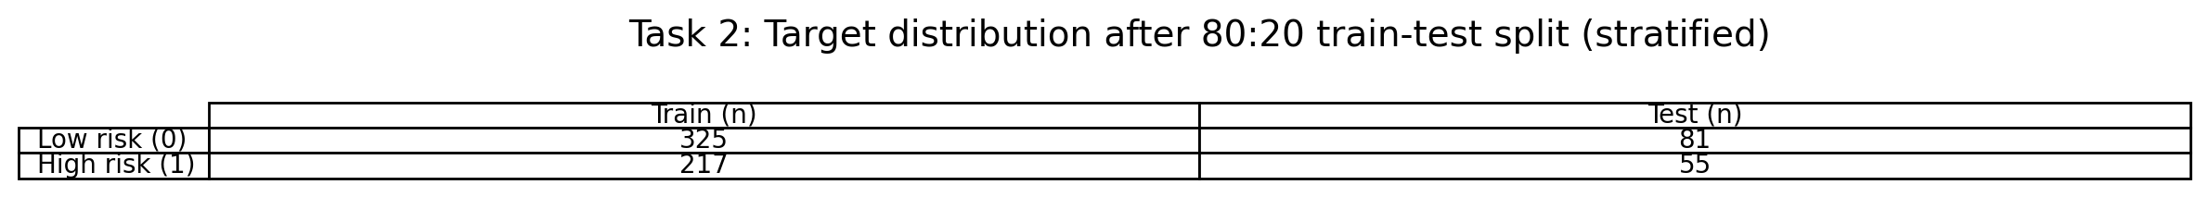
Implement and train a Random Forest classifier

- Implement a Random Forest classifier with 100 trees and random_state=42
- Train the model and evaluate its performance using:
  - Accuracy
  - Precision
  - Recall
  - F1-score

Screenshot required for project evaluation
- Single output showing all four metrics: Accuracy, Precision, Recall, and F1-score

<Paste the screenshot below>

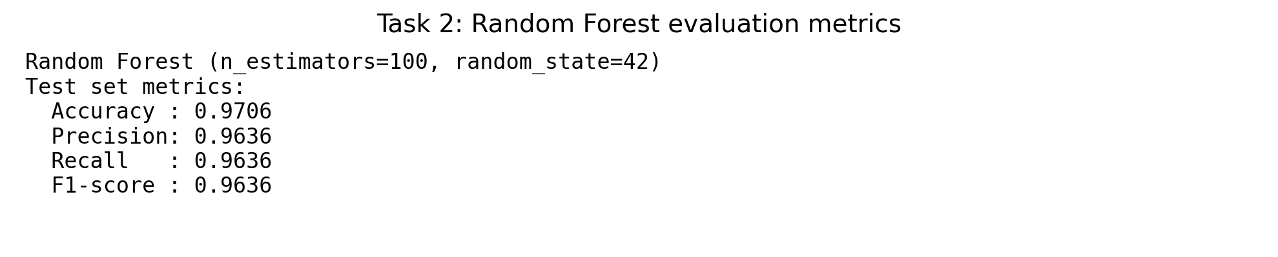
Visualize and save the trained model

- Plot the ROC–AUC curve
- Print feature importances
- Save the trained model as risk_model.joblib

Screenshots required for project evaluation
- Screenshot 1: ROC-AUC curve (clearly labeled with axes and AUC score)
- Screenshot 2: Top 3 feature importances with feature names and values

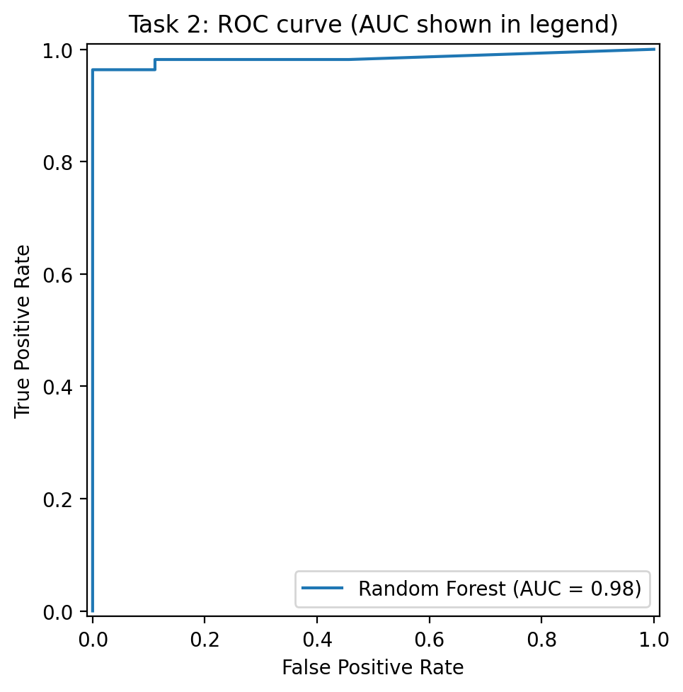
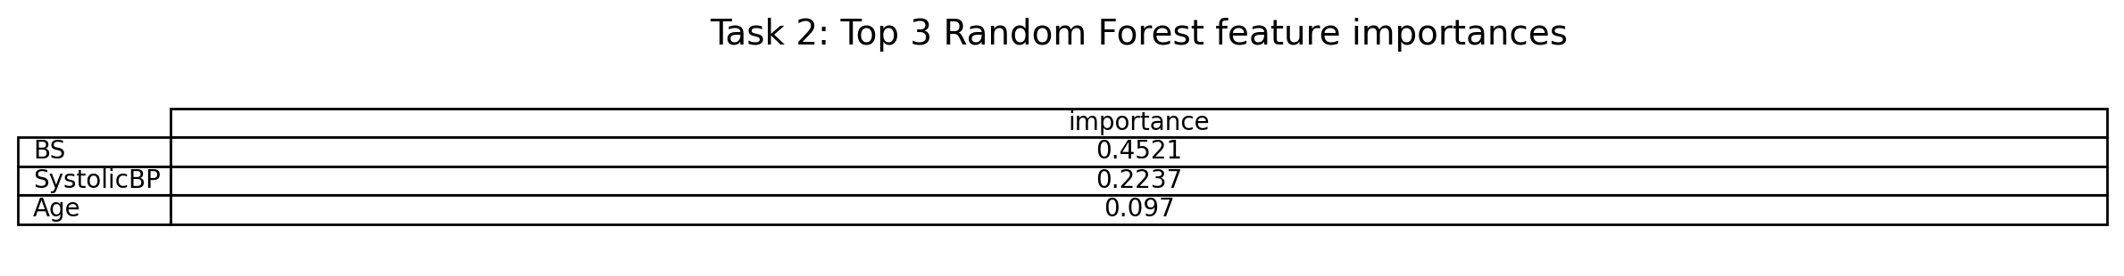

Task 3: Develop and assess a dense neural network model
Activity number | Activity
Scale data and train a Deep Neural Network

- Scale the data using StandardScaler
- Build and train a Deep Neural Network using:
  - Loss: binary_crossentropy
  - Optimizer: adam
  - Epochs: 50

Screenshot required for project evaluation
- Summary statistics for a few representative features showing mean close to 0 and standard deviation close to 1 of scaled training data

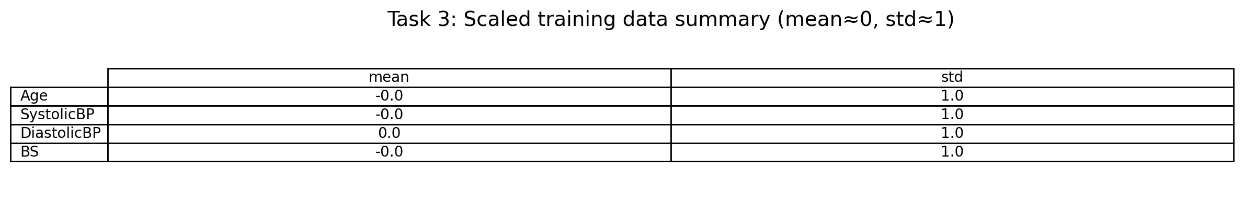
Evaluate and save the Deep Neural Network model

- Evaluate the model using Accuracy, Precision, Recall, and F1-score on the test dataset
- Save the trained model as risk_model_dnn.keras

Screenshot required for project evaluation
- Evaluation metrics (Accuracy, Precision, Recall, F1-score) confirming model evaluation completed successfully

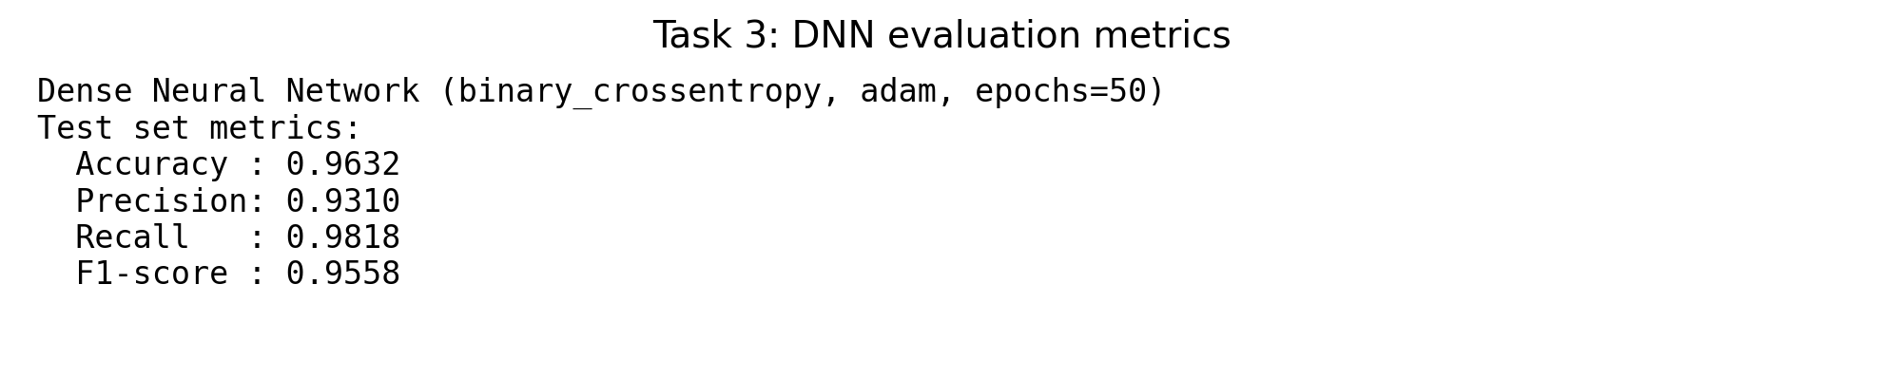

Task 4: Create and test a Gradio-based web application
Activity number | Activity
Create the web application

- Create a separate Python file named ai_risk_scoring_app.py
- Load the saved Random Forest model (risk_model.joblib)
- Build a Gradio-based web app that:
  - Allows doctors to enter patient details (e.g., blood pressure, sugar, temperature, heart rate)
  - Displays the predicted maternal risk level (e.g., “High Risk” or “Low Risk”)
- Test and verify the web app functionality

Screenshot required for project evaluation
- Screenshot 1: Gradio interface with example patient values entered in all input fields
- Screenshot 2: Prediction output showing the risk level

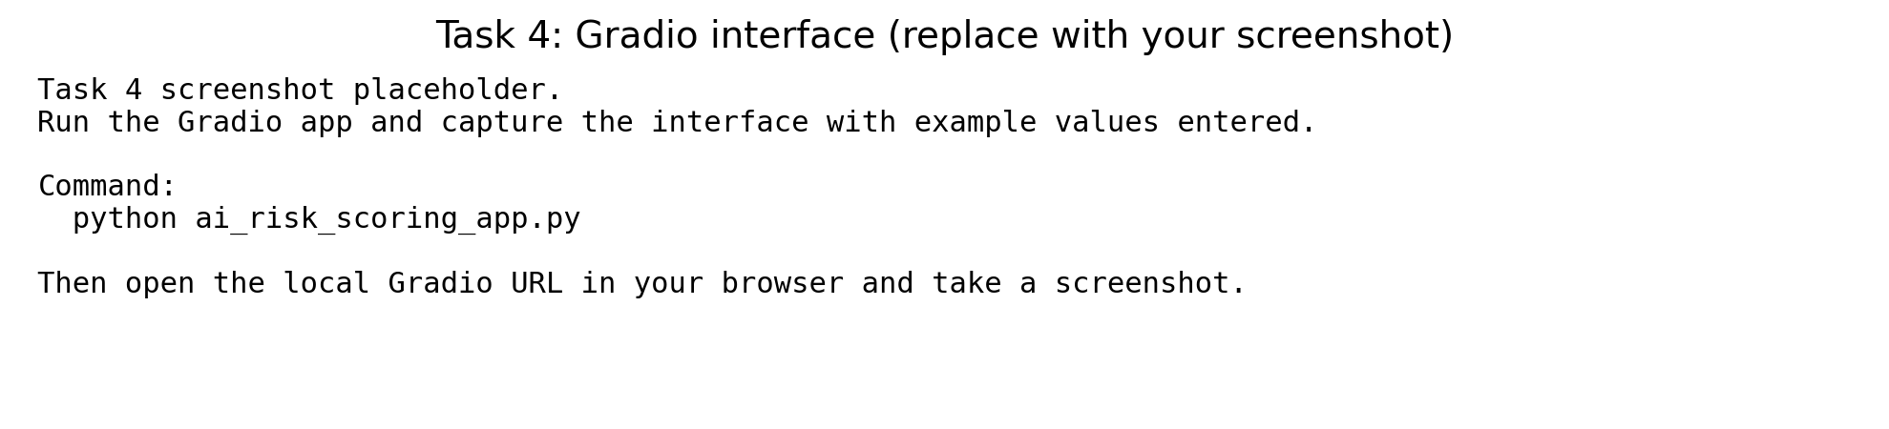


Appendix: Code used for this project (single-file submission)
Note: The peer-graded submission typically requires only this DOCX with screenshots. If your platform requires the app script, the full content is included below.

ai_risk_scoring_app.py
"""
AI-based maternal health risk scoring (Gradio)
Loads the trained Random Forest model (risk_model.joblib) and exposes a simple web UI
for clinical decision support simulation.
"""
import numpy as np
import joblib
import gradio as gr
MODEL_PATH = "risk_model.joblib"
# Load the saved model (sklearn Pipeline is supported)
model = joblib.load(MODEL_PATH)
FEATURE_NAMES = ["Age", "SystolicBP", "DiastolicBP", "BS", "BodyTemp", "HeartRate"]
def predict_risk(age, systolic_bp, diastolic_bp, bs, body_temp, heart_rate):
"""Return a human-readable risk label."""
x = np.array([[age, systolic_bp, diastolic_bp, bs, body_temp, heart_rate]], dtype=float)
pred = int(model.predict(x)[0])
label = "High Risk" if pred == 1 else "Low Risk"
return label
demo = gr.Interface(
fn=predict_risk,
inputs=[
gr.Number(label="Age (years)", value=28),
gr.Number(label="SystolicBP (mmHg)", value=120),
gr.Number(label="DiastolicBP (mmHg)", value=80),
gr.Number(label="Blood sugar BS (mmol/L)", value=7.0),
gr.Number(label="Body temperature (F)", value=98.6),
gr.Number(label="Heart rate (bpm)", value=78),
],
outputs=gr.Textbox(label="Predicted maternal risk level"),
title="Maternal Health Risk Scoring",
description="Enter patient vital signs to predict maternal risk level (Low vs High).",
allow_flagging="never",
)
if __name__ == "__main__":
demo.launch()

Maternal_Health_Risk_Analysis_Project_Notebook_AG.ipynb (JSON)
{
"cells": [
{
"cell_type": "markdown",
"id": "f28e4258",
"metadata": {},
"source": [
"# Maternal Health Risk Analysis (Project Notebook)\n",
"\n",
"This notebook follows Tasks 1–4 in the project brief."
]
},
{
"cell_type": "markdown",
"id": "8efaabe9",
"metadata": {},
"source": [
"## Setup"
]
},
{
"cell_type": "code",
"execution_count": null,
"id": "c6e75e73",
"metadata": {},
"outputs": [],
"source": [
"import pandas as pd\n",
"import numpy as np\n",
"import matplotlib.pyplot as plt\n",
"import joblib\n",
"\n",
"from sklearn.model_selection import train_test_split\n",
"from sklearn.pipeline import Pipeline\n",
"from sklearn.impute import SimpleImputer\n",
"from sklearn.preprocessing import MinMaxScaler, StandardScaler\n",
"from sklearn.metrics import accuracy_score, precision_score, recall_score, f1_score, roc_curve, auc, RocCurveDisplay\n",
"from sklearn.ensemble import RandomForestClassifier\n",
"\n",
"# Keras 3 (torch backend)\n",
"import os\n",
"os.environ[\"KERAS_BACKEND\"] = \"torch\"\n",
"import keras\n",
"from keras import layers\n",
"\n",
"DATA_PATH = \"Maternal_Health_Risk_Data_Set_Modified.csv\" # put CSV in the same folder as this notebook"
]
},
{
"cell_type": "markdown",
"id": "2bd7d876",
"metadata": {},
"source": [
"## Task 1: Prepare and clean the dataset"
]
},
{
"cell_type": "code",
"execution_count": null,
"id": "4b5fb006",
"metadata": {},
"outputs": [],
"source": [
"df = pd.read_csv(DATA_PATH)\n",
"print(\"Raw shape:\", df.shape)\n",
"print(df.head())\n",
"\n",
"# 1) Remove duplicates\n",
"before = len(df)\n",
"df = df.drop_duplicates()\n",
"print(\"Duplicates removed:\", before - len(df))\n",
"\n",
"# 2) Remove PII\n",
"df = df.drop(columns=[\"CitizenID\"])\n",
"\n",
"# 3) Median imputation (features only)\n",
"feature_cols = [\"Age\",\"SystolicBP\",\"DiastolicBP\",\"BS\",\"BodyTemp\",\"HeartRate\"]\n",
"target_col = \"RiskLevel\"\n",
"\n",
"X = df[feature_cols]\n",
"y = df[target_col]\n",
"\n",
"imputer = SimpleImputer(strategy=\"median\")\n",
"X_imputed = pd.DataFrame(imputer.fit_transform(X), columns=feature_cols)\n",
"\n",
"# 4) Normalize values (for Task 1 evidence)\n",
"minmax = MinMaxScaler()\n",
"X_norm = pd.DataFrame(minmax.fit_transform(X_imputed), columns=feature_cols)\n",
"\n",
"summary_stats = pd.DataFrame({\"mean\": X_norm.mean(), \"std\": X_norm.std(ddof=0)}).round(4)\n",
"summary_stats"
]
},
{
"cell_type": "markdown",
"id": "5b0d84f2",
"metadata": {},
"source": [
"## Task 2: Random Forest (no scaling)"
]
},
{
"cell_type": "code",
"execution_count": null,
"id": "5324e80a",
"metadata": {},
"outputs": [],
"source": [
"X_train, X_test, y_train, y_test = train_test_split(\n",
" X_imputed, y, test_size=0.2, stratify=y, random_state=42\n",
")\n",
"\n",
"print(\"Train distribution:\\n\", y_train.value_counts())\n",
"print(\"Test distribution:\\n\", y_test.value_counts())\n",
"\n",
"rf_pipe = Pipeline([\n",
" (\"imputer\", SimpleImputer(strategy=\"median\")),\n",
" (\"rf\", RandomForestClassifier(n_estimators=100, random_state=42))\n",
"])\n",
"rf_pipe.fit(X_train, y_train)\n",
"\n",
"y_pred = rf_pipe.predict(X_test)\n",
"acc = accuracy_score(y_test, y_pred)\n",
"prec = precision_score(y_test, y_pred, zero_division=0)\n",
"rec = recall_score(y_test, y_pred, zero_division=0)\n",
"f1 = f1_score(y_test, y_pred, zero_division=0)\n",
"\n",
"print(f\"Accuracy: {acc:.4f}\")\n",
"print(f\"Precision: {prec:.4f}\")\n",
"print(f\"Recall: {rec:.4f}\")\n",
"print(f\"F1-score: {f1:.4f}\")\n",
"\n",
"# ROC-AUC curve\n",
"y_score = rf_pipe.predict_proba(X_test)[:,1]\n",
"fpr, tpr, _ = roc_curve(y_test, y_score)\n",
"roc_auc = auc(fpr, tpr)\n",
"\n",
"fig, ax = plt.subplots(figsize=(6,5))\n",
"RocCurveDisplay(fpr=fpr, tpr=tpr, roc_auc=roc_auc, estimator_name=\"Random Forest\").plot(ax=ax)\n",
"ax.set_title(\"ROC curve (AUC shown in legend)\")\n",
"plt.show()\n",
"\n",
"# Feature importances (top 3)\n",
"rf = rf_pipe.named_steps[\"rf\"]\n",
"importances = pd.Series(rf.feature_importances_, index=feature_cols).sort_values(ascending=False)\n",
"importances.head(3)\n",
"\n",
"# Save model\n",
"joblib.dump(rf_pipe, \"risk_model.joblib\")\n",
"print(\"Saved risk_model.joblib\")"
]
},
{
"cell_type": "markdown",
"id": "9ad1ce07",
"metadata": {},
"source": [
"## Task 3: Dense Neural Network (StandardScaler)"
]
},
{
"cell_type": "code",
"execution_count": null,
"id": "c253f5e1",
"metadata": {},
"outputs": [],
"source": [
"scaler = StandardScaler()\n",
"X_train_scaled = scaler.fit_transform(X_train)\n",
"X_test_scaled = scaler.transform(X_test)\n",
"\n",
"scaled_stats = pd.DataFrame(\n",
" {\"mean\": X_train_scaled.mean(axis=0), \"std\": X_train_scaled.std(axis=0, ddof=0)},\n",
" index=feature_cols\n",
").round(4)\n",
"scaled_stats.head(4)"
]
},
{
"cell_type": "code",
"execution_count": null,
"id": "5df7ac6b",
"metadata": {},
"outputs": [],
"source": [
"dnn = keras.Sequential([\n",
" layers.Input(shape=(X_train_scaled.shape[1],)),\n",
" layers.Dense(32, activation=\"relu\"),\n",
" layers.Dense(16, activation=\"relu\"),\n",
" layers.Dense(1, activation=\"sigmoid\")\n",
"])\n",
"\n",
"dnn.compile(optimizer=\"adam\", loss=\"binary_crossentropy\", metrics=[\"accuracy\"])\n",
"dnn.fit(X_train_scaled, y_train.to_numpy().astype(\"float32\"), epochs=50, batch_size=32, validation_split=0.2, verbose=0)\n",
"\n",
"y_prob = dnn.predict(X_test_scaled, verbose=0).reshape(-1)\n",
"y_pred_dnn = (y_prob >= 0.5).astype(int)\n",
"\n",
"acc = accuracy_score(y_test, y_pred_dnn)\n",
"prec = precision_score(y_test, y_pred_dnn, zero_division=0)\n",
"rec = recall_score(y_test, y_pred_dnn, zero_division=0)\n",
"f1 = f1_score(y_test, y_pred_dnn, zero_division=0)\n",
"\n",
"print(f\"Accuracy: {acc:.4f}\")\n",
"print(f\"Precision: {prec:.4f}\")\n",
"print(f\"Recall: {rec:.4f}\")\n",
"print(f\"F1-score: {f1:.4f}\")\n",
"\n",
"dnn.save(\"risk_model_dnn.keras\")\n",
"print(\"Saved risk_model_dnn.keras\")"
]
},
{
"cell_type": "markdown",
"id": "5d68030e",
"metadata": {},
"source": [
"## Task 4: Gradio app"
]
},
{
"cell_type": "code",
"execution_count": null,
"id": "5c9683b3",
"metadata": {},
"outputs": [],
"source": [
"# The project requires a separate file named ai_risk_scoring_app.py.\n",
"# Use the provided script in the submission bundle and run:\n",
"# python ai_risk_scoring_app.py"
]
}
],
"metadata": {
"kernelspec": {
"display_name": "Python 3",
"name": "python3"
}
},
"nbformat": 4,
"nbformat_minor": 5
}

Run instructions (local):
1) Put ai_risk_scoring_app.py and risk_model.joblib in the same folder.
2) Install dependencies if needed:
pip install gradio joblib scikit-learn numpy pandas
3) Run:
python ai_risk_scoring_app.py
4) Take screenshots of the Gradio UI and the prediction output and paste into Task 4 in this DOCX (if required).

